SHMOO Test Data Analysis
Die-Level VDD/Frequency Characterization — Binning & Screening Recommendation
Source: SHMOO_1000_Point_Dataset.csv | Lot A001, Wafer W001, Die D0001 | Prepared: August 12, 2026

1. Executive Summary — AI Recommendation
Across 1,000 VDD x Frequency test points (0.80–0.99 V, 1.00–1.98 GHz, 85°C), the device passed 589 points (58.9%) and failed 411 (41.1%). The pass/fail boundary is highly linear (R² = 0.99): Fmax(GHz) ≈ 3.56 × VDD(V) − 1.62. Two distinct failure mechanisms are present — FREQ_MARGIN (306 fails, 74%) tracks the voltage/frequency boundary as expected, while TIMING (105 fails, 26%) concentrates in a small subset of patterns and represents a separate, pattern-specific risk that a simple frequency guardband will not fully screen.
Recommendation: Set the production screening operating point at VDD ≥ 0.90 V and Frequency ≤ 1.50 GHz, which sits inside the observed pass region with margin, then add a second, targeted screen using the ATPG patterns responsible for TIMING fails (see Section 5) rather than relying on frequency guardband alone.

2. Methodology
The dataset represents an at-speed scan (SCAN_AT_SPEED) SHMOO sweep of a single die (D0001, Lot A001, Wafer W001) across 20 VDD steps (0.80–0.99 V, 0.01 V increments) and 50 frequency steps per voltage (1.00–1.98 GHz, 0.02 GHz increments), using 100 unique ATPG patterns, all at 85°C junction temperature. Each of the 1,000 points records Test_Result (PASS/FAIL), Failure_Code (FREQ_MARGIN, TIMING, or NA), and supporting electricals (current, leakage, timing, margin).

3. SHMOO Plot
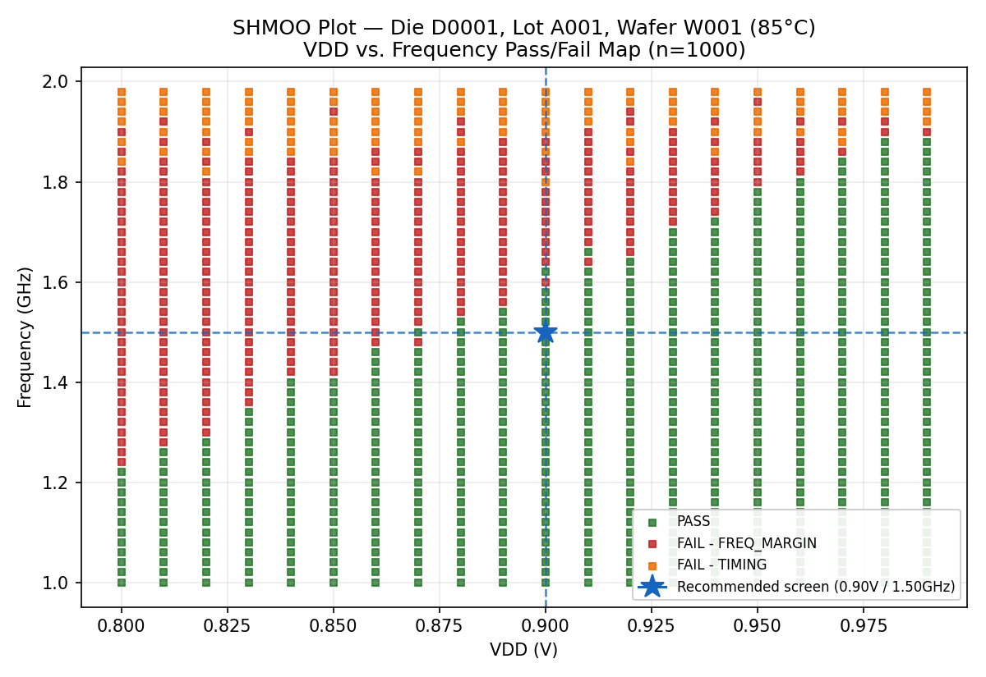
Green = PASS. Red = FAIL (FREQ_MARGIN). Orange = FAIL (TIMING). The dashed blue lines mark the recommended production screening point (0.90 V / 1.50 GHz).

4. Pass/Fail Boundary & Yield by Voltage
Yield rises monotonically with VDD, from 24% at 0.80 V to 90% at 0.98–0.99 V. The Fmax-vs-VDD boundary is linear and well-behaved (no erratic jumps), indicating a stable, well-characterized device with no anomalous failure clusters outside the expected voltage-scaling trend.
VDD (V) | Fmax @ Pass (GHz) | Yield (Pass %)
0.80 | 1.22 | 24%
0.81 | 1.26 | 28%
0.82 | 1.28 | 30%
0.83 | 1.34 | 36%
0.84 | 1.40 | 42%
0.85 | 1.40 | 42%
0.86 | 1.46 | 48%
0.87 | 1.50 | 50%
0.88 | 1.52 | 54%
0.89 | 1.54 | 56%
0.90 | 1.62 | 62%
0.91 | 1.66 | 66%
0.92 | 1.64 | 66%
0.93 | 1.70 | 72%
0.94 | 1.72 | 74%
0.95 | 1.78 | 80%
0.96 | 1.80 | 82%
0.97 | 1.84 | 86%
0.98 | 1.88 | 90%
0.99 | 1.88 | 90%

5. Failure Mode Analysis

5.1 FREQ_MARGIN (306 fails, 74.5% of fails)
These failures occur exactly where expected — above the die's maximum operating frequency at a given VDD (all have negative timing margin). This is normal voltage/frequency-limited behavior and is the mechanism a standard SHMOO-derived guardband is designed to catch.

5.2 TIMING (105 fails, 25.5% of fails)
TIMING fails also all carry negative margin (range −0.75 to 0 GHz), but they are concentrated in a small subset of the 100 ATPG patterns rather than spread evenly: patterns ATPG_045–050 and ATPG_096–100 alone account for roughly half of all TIMING fails. This clustering suggests specific critical paths or pattern-sensitive structures (rather than generic frequency scaling) are driving these failures — a distinct risk that a voltage/frequency guardband alone will under-screen.
- Top contributing patterns: ATPG_049 (10 fails), ATPG_050 (10), ATPG_100 (10), ATPG_048 (9), ATPG_098 (9), ATPG_099 (9).

6. Binning / Screening Recommendation
- Primary production test point: VDD = 0.90 V, F = 1.50 GHz — inside the pass region across the full sweep, with positive timing margin observed at this point in the source data.
- Add guardband: because this characterization is based on a single die, apply an additional margin (e.g., +20–30 mV VDD or −5% frequency) before finalizing production limits, to absorb die-to-die and lot-to-lot process variation not captured here.
- Two-tier screen: (1) a fast frequency/voltage sweep to catch FREQ_MARGIN-type fails, plus (2) a short, targeted pattern set built from the top TIMING-failing patterns (ATPG_045–50, ATPG_096–100) to catch pattern-specific critical-path fails that frequency guardband misses.
- Consider a lower-bin/low-power grade around VDD 0.83–0.85 V (F ≈ 1.34–1.40 GHz, ~36–42% yield at this single-die sample) only if downstream demand justifies the yield loss; otherwise screen out below 0.90 V.
- Next step: repeat this SHMOO sweep across additional dies/wafers/lots before locking production limits — one die is insufficient to characterize process spread.

7. Caveats
This analysis is based on a single die at a single temperature corner (85°C). Production screening limits should incorporate multi-die, multi-lot, and multi-temperature (e.g., cold/hot corner) SHMOO data before being finalized in the test program.

